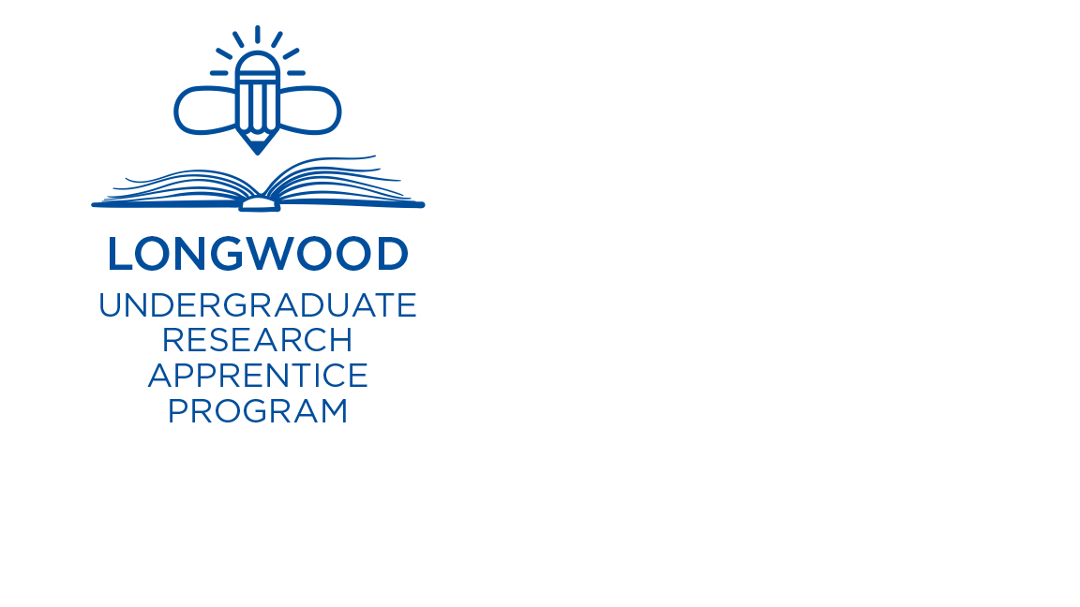 | Spring 2025  UNDERGRADUATE RESEARCH APPRENTICE PROGRAM (URAP)  APPLICATION

The Office of Student Research (OSR) is pleased to invite student-faculty teams to apply for the Spring 2025 Undergraduate Research Apprentice Program (URAP). This program is open to all first-, second- and third-year full-time undergraduate students in all majors. URAP is a semester-long research experience where faculty introduce students to the research process and research topics in their discipline and supervise an independent student research and creative inquiry project. This program provides students with an opportunity to engage in preliminary research and creative inquiry projects, which may then form the basis for a continuing research or inquiry-based activity. Students will also be introduced to the process of designing and conducting independent research and inquiry projects through concurrent enrollment in a one-credit RSCH 200-Introduction to Research and Inquiry course. At the end of the program, students will summarize and share their research and inquiry projects through presentation at the 2025 Spring Student Showcase for Research and Creative Inquiry, submission to Incite, or submission of a proposal for the Longwood Senior Thesis program. OSR has designated several spots for student projects focused on Diversity, Equity, Inclusion, and Belonging (DEIB) research topics.

This introductory experience is particularly valuable for students who may want to pursue more advanced research and inquiry projects during a summer or in-semester research experience in the future. Faculty will have the opportunity to mentor an undergraduate student one-on-one.

Students will register for 1-credit of research in their discipline AND RSCH 200- Introduction to Research and Inquiry (a 1-credit class). Students will be responsible for signing up for the 1-credit of research in their discipline, the 1-credit RSCH 200 class, and for meeting Longwood University requirements for academic credit. URAP students may not participate in another funded research and inquiry program simultaneously, such as Perspectives on Research in Science and Mathematics (PRISM) or Longwood Senior Thesis. Faculty mentors will receive a $500 stipend.

Applications will be evaluated based on the criteria in the Spring 2025 URAP Application Rubric. Applications are due Monday, October 14th by 5:00 p.m.

Program Requirements
Student Participants | Faculty Mentors
Time commitment: Students are expected to spend 3 hours per week on their research and creative inquiry project including having weekly in-person meetings with the faculty mentor. | Time commitment: Faculty are expected to mentor the student throughout the program and to meet with the student in person at least 1 hour per week.
Professional development: Students are expected to spend 3 hours per week attending the RSCH 200 class and completing required assignments and activities.
Work product: Students are expected to:  - Present their research and inquiry project at the Spring 2025 Student Showcase for Research and Creative Inquiry, submit a paper to Incite, or submit a proposal for the Longwood Senior Thesis Program.  - Complete the Research Skills Surveys.  - Complete the Final Project Summary Report. | Work product: Faculty are expected to:  - Ensure students submit to the Spring 2025 Student Showcase, submit a paper to Incite, or submit a proposal for the Longwood Senior Thesis Program.  - Complete the Research Skills Surveys.  - Submit required paperwork, including Research Syllabus and Final Report.
Eligibility
Faculty. URAP is open to tenured and tenure-track faculty members, clinical educators, and lecturers from all disciplines, programs, and colleges. Faculty-student teams are limited to one faculty member and one student. Faculty may mentor more than one student in a semester if the students are working on different projects.

Students. URAP is open to all first-, second-, and third-year full-time undergraduate students in good academic standing who will return to the University for the next academic year. Students graduating in the current academic year are ineligible.

This program is intended to be an introductory experience for students who may want to pursue more advanced research and inquiry projects in the future. The purpose of this program is to encourage new faculty/student pairs. While each faculty/student pair can only participate in the program once, we hope that faculty/student pairs will continue to work on research endeavors even after the conclusion of the program.

How to Apply
Students should electronically complete and submit a PDF (no larger than 2 MB) of the completed application to Dr. Shayla Walker, Director of the Undergraduate Research Apprentice Program (walkerse4@longwood.edu), by 5:00 p.m. on Monday, October 14th. Please direct questions to Dr. Shayla Walker, Director of the Undergraduate Research Apprentice Program.

Spring 2025 UNDERGRADUATE RESEARCH APPRENTICE PROGRAM (URAP) APPLICATION

THIS SECTION SHOULD BE COMPLETED BY THE STUDENT.

Instructions: Students should electronically complete and submit a PDF (no larger than 2 MB) of the completed application to Dr. Shayla Walker, Director of the Undergraduate Research Apprentice Program (walkerse4@longwood.edu), by 5:00 p.m. on Monday, October 14th. Please direct questions to Dr. Shayla Walker, Director of the Undergraduate Research Apprentice Program.

Students are strongly encouraged to seek assistance from their faculty mentor or from OSR staff when completing the application.

STUDENT INFORMATON
Name |  | Email
Department |  | Level (1st year, 2nd year, or 3rd year)
Faculty Mentor |  | Email
Title of Project

IRB: Does your research involve human subjects? If yes, attach documentation of Institutional Review Board exemption or approval. See http://www.longwood.edu/studentresearch/institutional-review-board-irb/ | ___ Yes | ___ No
IACUC: Does your research involve animal subjects? If yes, attach documentation of Institutional Animal Care & Use Committee’s approval (cover sheet only). See http://www.longwood.edu/studentresearch/institutional-animal-care--use-committee-iacuc/ | ___ Yes | ___ No
Permission: Do you give your permission to use information from this form in a release as well as promotional materials for OSR? | ___ Yes | ___ No

By signing this form, I confirm I understand that I am expected to meet all program requirements described in the Call for Applications.

Signature | Date

THIS SECTION SHOULD BE COMPLETED BY THE STUDENT.

PROJECT INFORMATION: All answers must use language suitable for a reader outside your discipline.
- Title: State the title of your research or creative inquiry project. Example: “Women during the Reconstruction era.” (50 words max)
2. Purpose: Describe your research or creative inquiry question/topic. Please be specific and use plain language. Example: “I want to investigate whether women were able to own property during the Reconstruction era. Many men, particularly in the South, did not return from the Civil War. Reconstruction allowed African Americans to exercise certain rights that were previously denied, such as voting and property ownership. I wonder if this was also the case with women.” (150 words max).
3. Significance: Explain the significance of your proposed research or creative inquiry project. Why is your project important and what does it add to our knowledge of the subject? Please be specific and use plain language. Please include in-text citations of your sources. Example: “If women in the nineteenth century gained the ability to own property during Reconstruction, it would alter the way we see Southern women, who are often portrayed as completely dependent on men.” (150 words max)
4. Research Interest and Preparation: Explain how you became interested in your project. Have any previous courses or other experiences helped to prepare you to undertake the project? (150 words max)
5. Benefits: How will doing this project benefit you? Why do you want to undertake this research or creative inquiry project? How will participating in this experience support your future career and/or personal goals? (150 words max)
6. DEIB Focus: Does your project have a Diversity, Equity, Inclusion, and Belonging (DEIB) focus? If yes, please explain how the project focuses on DEIB research topics. (150 words max) | ___ Yes | ___ No

Spring 2025 UNDERGRADUATE RESEARCH APPRENTICE PROGRAM (URAP) APPLICATION

THIS SECTION SHOULD BE COMPLETED BY THE FACULTY MENTOR.

PLEASE COMPLETE AND SIGN.
Faculty mentors should complete the Faculty Application, sign it, and return it to the student to include with their application. This is a required part of the application.

FACULTY INFORMATION
Name of Applicant
Faculty Mentor |  | Email
Department
Department Chair |  | Email

RESEARCH INFORMATION
1. Research or creative inquiry question: Briefly describe your student’s research and inquiry project in language that those outside of your discipline will understand and explain how it is significant to your field/discipline. If applicable, also explain how your student’s project focuses on diversity, equity, inclusion, and belonging topics. (150 words max)
2. Student work: How will the student be involved in this research and inquiry project? Explain what specific tasks your research apprentice will perform. (150 words max)
3. Student learning: What specific learning outcomes are associated with this research and inquiry project? Explain what specific skills and/or knowledge your student will gain. These learning outcomes should also be reflected in the syllabus you submit upon acceptance to the program. (150 words max)
4. Mentoring strategies: What strategies will you use to mentor your student? You may include how you will draw on your previous experience mentoring students. (150 words max)
5. Faculty roles: As the faculty mentor, what will your roles and responsibilities be in supervising and potentially contributing to the research project? (150 words max)

By signing this form I confirm that I have: 1) reviewed my student’s application, 2) confirm the viability of the project, 3) confirm that the student will produce a submission for Student Showcase, Incite, or Longwood Senior Thesis, 4) agree to meet all program requirements for faculty mentors and ensure that the student completes all requirements as described in the Call for Applications.
Signature (electronic signature is acceptable) |  | Date

